Waltham Forest Parent Forum Consultation on Services and Support May 2021
Consultation
Parent carers of children and young people with Special Educational Needs and/or Disabilities (SEND) were consulted via an online survey about services and support. The results below come from 107 responses from 29th March to 17th May 2021.We intend to redo the survey at the end of the financial year so that we can see where improvements have been made.
Background
Waltham Forest Parent Forum) is a collective of parent carers from over 1,390 member families across Waltham Forest. In addition to this, WFPF has an online community of over 1,500. WFPF has been the strategic voice of parent carers working in partnership with Waltham Forest Council (LBWF) and the Clinical Commissioning Group (CCG) and other health partners since 2008. It is funded through a direct DfE grant (administered through Contact) and by LBWF.
Questions
Parents were asked a series of questions. Some were multiple choice and some simply required parents’ thoughts. Below are the questions, the responses in terms of the % of parents who responded, the number of parents that equated to and any comments that were made.
Most of the parents who responded had children aged 5-11(46.73%) in mainstream primary schools (36.45%) with autistic children/young people (67.29%) who have an Education, Health Care Plan (63.55%)
Headlines
- The EHCP process is seen as a stressful and frustrating process by 27% with poor communication (27%) throughout the process.
- Only 14.95% of those with EHCPs think they are of excellent quality.
- 57.95% of parents feel that their child’s needs have been identified very well/ quite well by education, 61.32% by health but only 35% by social care.
- Only 9% of parents whose children are at SEN support, know that the SEN Support plan is reviewed at least 3 times a year
- 34.5% of those with an EHCP have had an annual review within the year.
- 36% of parents know who their SEND Officer is
- Two thirds of parents are happy/reasonably happy with how their child’s needs are being met by education, health and social care services.
- 56% of parents rate communication with the SEND team as poor or inadequate.
- Only 1/3 of parents access short breaks.
- 78% of parents don’t think there are sufficient leisure activities for children with SEND.
- 52% of parents find it difficult to find information about services.
- 67% have never heard of the Local Offer.
- Top 5 topics parents would like us to tackle: EHCP Quality- legally compliant; Communication; Ensuring SEN Support is monitored; Ensuring Annual Reviews take place; School Anxiety.
1. If you are going through the EHCP process, or have been through it in the last 12 months, what worked well? (Please select all that apply)
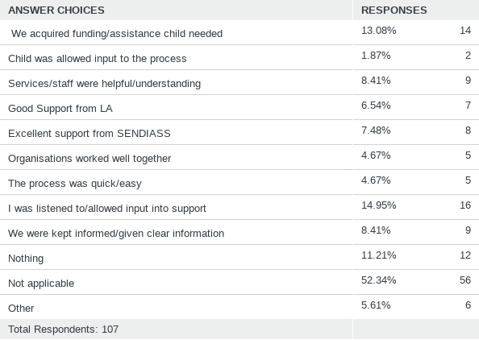

Comments
- Too early in the process. No decent support so far
- St. John’s staff are excellent. They understand my child’s needs and what support he needs.
- Our WF SEND Home Visitor has been very supportive. The assessment level of the EHCP was systematic, conscientious and all the deadlines met. The problem is with putting the support in place including the getting the school of choice!

- What hasn't worked well through the EHCP process so far? (Please select all that apply)
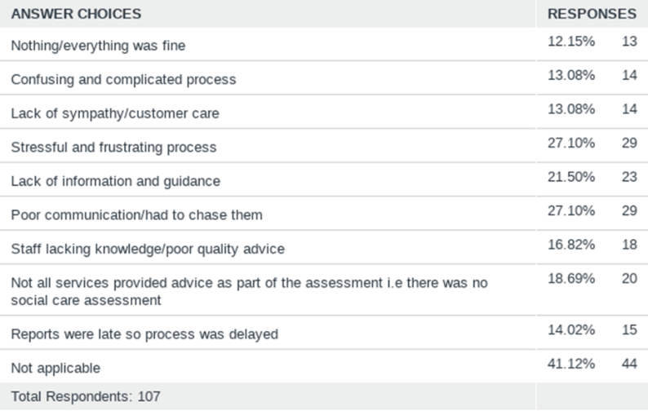
Comments
- Dreadful process!
- It's been utter hell. Almost nothing has worked as it should have
- I have been told that it's probably not worth bothering to apply for an EHCP as the bar is now very high for being accepted. I feel this is wrong. My child is high functioning and academically very able, which is why we probably wouldn't get an ECHP, but he suffers high anxiety and depression, and often expresses suicidal thoughts. I think the system is failing children like him.
- The EHC process works but the actions i.e. speech therapy 121 has never been provided as per EHC plan
- Should have applied a long time ago but delays in diagnosis, and the complicated, long, stressful process and need to gather evidence caused massive delays
- Deliberate incompetence.
- The school was the one preventing for the EHCP to be done . Once they did it went smoothly
- All was great but wish there was more support
- No response to initial submission so had to chase to confirm receipt.
- EP report was not specific and so had to be rewritten. School and EP opposed this and claimed that school was meant to interpret child's needs.
- Had an ehcp review as he was leaving/ being refused his final year of college which was college focused (?!) despite it being irrelevant to the coming year. Nothing since at all despite knowing he was not in education or employment
- LA never turn up and don’t even give an excuse. And I’ve come to realise over the years that they are useless anyway so don’t need them there.
- The process doesn’t work for a child with a life limiting degenerative condition, 20 weeks is far too long for a process to take
- Mediation and solicitor was used through process
- Lack of support from school regarding decision to file
- General poor service, high turnover of staff
- We have used this service for 15 years and it has been poor throughout with little or no support from SEND Officers who change throughout the year
- The SEND panel is not fit for purpose. Just an awful experience
- Had our review in July 2020. Still waiting for updated EHCP. Are nearly due another annual review so it's ridiculous.
- Unfortunately, most of the difficulties are created by the SENCOs especially from mainstream schools. They don't have empathy and it feels like they are working towards the wishes of the schools, whom for most is not to have children with disabilities. They need to be more educated and understand the term inclusive, create support rather than warding off parents to find support in special schools. Special schools are getting oversubscribed and schools with provision units too. There is need for mainstream schools to be more accommodative.

3. If your child has an EHCP, do you think it is a good quality plan- e.g are all your child's needs identified, is it specific, are provisions quantified, does it have reasonable outcomes?
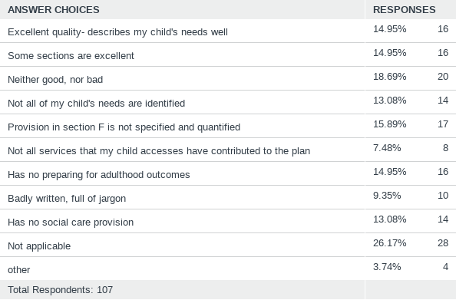
Comments
- The sections we had input into aren't great as the SEND officer failed to copy and paste them correctly. After mentioning this at the co-production meeting, the plan was then rushed through without us having another quick look. I'm not happy with it and have not been able to get it changed.
- Process confusing not sure I fully understand all I need and how all process works.
- I’ve replied neither good nor bad as I’ve never seen a final copy of my child’s EHCP which was converted from a Statement in 2014 when he switched from nursery to primary school
- poorly drafted so it is difficult to see what provision matches which need/ outcome
- Not quite sure what 19-25 support is supposed to look like. It seems neither does the send officer without the backing of an educational setting...
- The plan was very poor and was not adequately updated with new diagnosis’ for 2 years! I issued a complaint and c/c’d in the team manager and still received not even a courtesy response. When the information was eventually added to his plan (after lots of chasing), the quality was poor and we as parents had to make the suitable amendments.
- Does not meet his needs. No one actually follows the plan. Not fit for purpose
- It has things in his plan from when he was 3 that are not applicable now
- Full of typos, not always correct info about my child. It has got better at every review - but only because I have spent months and months writing sections and changing for the SEN officer. It is extremely difficult to get meaningful updates. I find changes are often riddled with errors and really generalised rather than being specific.

4. Please tell us how well you think your child/young person's needs have been identified by
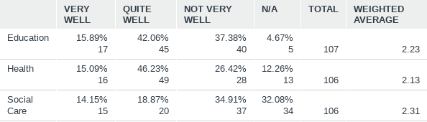
Education Comments
- The lack of communication has been disappointing. The entire process is incredibly slow and has taken us almost 2 years to get an EHCP even though my son’s problems were clear before he even began nursery, and even now the EHCP has not been finalised. He was known to local healthcare before he began nursery, but the school still insisted on "3 terms of evidence" and this has stretched way into his reception year due to the Covid pandemic. This delay has been totally detrimental to my son’s progress and I regret going through the school at all for this. I wish we were advised sooner to apply for EHCP ourselves instead of relying on the school which in my opinion has deliberately delayed things for financial reasons.
- Fought for support for 2 years before SENCO involved. She has been fantastic since then
- Primary senco dismissed camhs diagnosis, laughed at doctor from camhs, said adhd medication made children into zombies, said too much work to apply for plan, refused to get ep report, insisted not eligible for ehc plan as ep produced chart saying child had to be more than 3 years behind in every area. Refused to consider individual needs. Refused to review appropriateness of group interventions. Got ehc plan in year 8 finally. Diagnosis by camhs in year 1. School finally applied for ehc plan in 2014 but still refused to get ep or slt report. Council refused to assess on basis of illegal criteria ie. Child needed to have complex and multiple needs. They decided having asd and adhd and making no progress in school and being 3 or more years behind peers and anxiety driven difficult behaviour to avoid school, was not sufficient to need a plan. Secondary school did not provide LSA support for all lessons, did not provide learning mentor as recommended by ep, did not support referral back to camhs for anxiety nor offer counselling, did not provide transition to post16 support including careers guidance. School-home communication very poor and difficult. No contact with LSA permitted. In college failure to provide learning mentor in accordance with ehcp and effect of covid reducing course hours to one day of classroom learning maths only then only online led to son dropping out.
- Their primary school labelled my child as a "naughty pupil" and allowed them to be bullied, developing an apparent dislike towards them and blaming them for being bullied. They ignored my child's struggles for years. My child has been referred to Children's Occupational Therapy after I begged my GP to refer them. The school refused to acknowledge their diagnosis and their anxiety which resulted in an emergency referral to CAMHS. Their secondary school is much more supportive, but the school has done nothing to support him initially, despite having a conversation with my child's occupational therapist. They, in fact, lost all my child's reports and claimed they've never had a conversation with the OT. They started taking actions after we kept sending them polite reminders in response to negative referrals and threats from the teachers. Now there are some measures in place to support my child, which are helpful, but it's a constant fight .
- My child’s needs have been identified fairly well by his school. The LA has had no involvement in my child since Yr1 (now Yr5).
- Not well at all at primary school; ok at secondary school through our advocacy.
- If a child struggles to go to school and has no known ‘external’ reason (e.g. trauma), they should be supported and assessed immediately and continually. Instead, he was treated as NT until he was 11 and told he was wrong and ‘should’ be able to do things NT kids can do. We’ve had threats from the council even though it is the LA that is failing to provide an education. He’s had no TA at school, no appropriate academic or emotional support, a lack of understanding.
- The school have been good, even with the lack of funding they receive.
- my child's school has been brilliant, lot of reports from professionals and many interventions have been put in place, where possible due to Covid 19, progress has been made but slow.
- We don't understand why SEN is so poorly funded. Until we have an assessment the education system is not supporting our child's needs.
- School reluctant to take on concerns hence delay in screening. Now in year 4 screening point to one issue being dyslexia. All those years wasted.
- Excellent O.T and SALT
- School has been useless in its support. Cannot wait to see the back of it.
- Our WF SEND Home Visitor has been very supportive but there isn’t a nursery setting that could accommodate my son as his needs are too complex.
- Nursery identified her needs well but primary school (reception) has been dismissive.
- School refused to acknowledge my concerns or support or refer. This had to be completed by GP
- He was diagnosed with Dyslexia in year 6. I gave the report to his secondary school at year 7. They never put him on the SEND register, only found out in year 11 that he wasn’t getting extra support in exams as specified on his report. I was told that his primary school did not transfer any records to the secondary school, although it was them that organised for his Dyslexia assessment. The Senco at secondary school left and with them any information they were holding for my son. Have now got the ball rolling for possible EHCP referral., but only after i contacted a private consultant. Was being brushed off by school.
Health comments
- She's still not been tested for ADHD after months of waiting.
- I am angry at the lack of expertise among GPs for autism. Looking back with experience, it was clear to me that my son showed obvious autistic traits yet despite several visits to a local GP about his speech delay, autism or a learning disability were not even mentioned. We were sent for a hearing test which was fine. Then we were finally sent to Speech and Language therapist and that's when we were told that he may be on the autism spectrum. It then took well over a year for an autism assessment. I believe we have lost 2 years in potential help for my son due to a lack of knowledge from GPs and the slow process to diagnose autism. The entire system is broken and it has let people down. If I could go back in time I would have gone down the private healthcare route as the NHS is hopeless when it comes to dealing with children that have autism. A knowledgeable GP should have immediately flagged concerns as he showed very obvious signs of autism such as delayed speech, no eye contact, not responding to his name etc.
- Dreadfully long process. Went private in desperation to move the process for an EHCP application along
- GP still refusing to do health check. Very poor referrals so unsuccessful.
- I don't feel the school is doing much to understand my child's mental and physical health.
- Shows signs of anxiety and compulsive behaviour which have been dismissed and not investigated fully.
- Failures in the education setting have severely affected his mental health. This is not an individual-school problem but the entire education and educational support system. Still he has been continually pressured to be in environments that cause him anxiety and lead to depression, and made to feel guilty and shame
- WF Occupational Health has been shocking, the state of the service is disgraceful. WF Child Development Team have been helpful but waiting lists to access paediatric services and referrals was too lengthy. Wheelchair services were very helpful. Lack of parental support groups during Covid has been difficult.
- The assessment by the paediatrics team was done thoroughly, but it hasn't been actioned as anything useful at this stage.
- Struggling with mental health
- NEEDS CONTINUOUS PHYSIOTHERAPY WHICH IS NOT PROVIDED. NO HEALTH REVIEWS, NO SALT THERAPY GIVEN
- After my son was discharged from Wood Street we have no health support. I have serious concerns I think need to be addressed about his health but no idea how to. I also think he needs OT and physio input but that has been extremely difficult to access.
- Health has never contributed to my child’s EHCP, despite her having health needs arising from her ASD (e.g. problems due to limited diet)
- She's had severe mental health issues that have not been addressed at all!
Social Care Comments
- Have not had any luck with transferring to short break personal budget despite many requests. Was informed citizen's Advice would be managing the change from SB Hours to PB but despite a one year wait no response. For the previous yr ending 2021 March we still have not transferred to a personal budget. The last 2yrs SB have been of no tangible use as hrs were not used. Need a better local offer as the options are too limited and leave us without much needed support.
- Early Help gave generic parenting advice. He was undiagnosed awaiting assessment. It was a good space for me as a parent to talk things through, but the tips weren’t appropriate. There’s been no direct support for him in this area at all.
- interventions have been put in place to help my child make the right social and emotional choices.
- Irem from Early Help Team has been brillian.t
- Social care has never been involved in my child’s EHCP. She receives short break hours but have not found any good ways to use them.

5. Please tell us how well your views were taken into account when your child/young person's needs were identified by
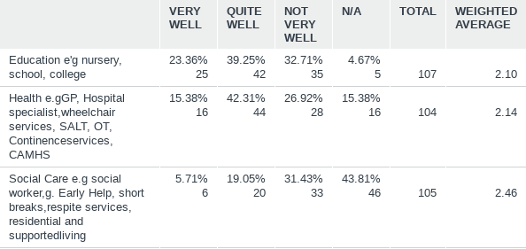

6. How satisfied are you with the ongoing monitoring and assessment of your child/young person's needs by education, health and social care?
- I was informed that I could go to the GP and express my concerns so as to get the appropriate referrals. The GP literally sent me away and said "How do I know your child has autism?" After hustle and bustle I was given another doctor who mentioned the previous GP was Locum and did not understand the protocol. It was unnecessary to have to go through that. My child's need were not taken in to account, we had to wait long to see the doctor at the reception, my child was not cooperative with check ups and the doctor seemed not to have a clue of how to go around him. It was a hectic stressful process in comparison to the community paediatrician who made it so favourable for my son and in turn he cooperated well.
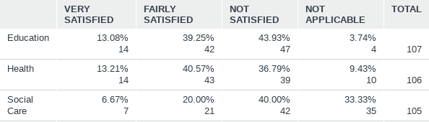
Comments
- We have had very little actual support from local healthcare. There have been a few parenting sessions on autism and some videos but that's about it. I would expect speech and language therapy, occupational therapy, help with eating, sleeping etc. but there has been none of this. Covid has been used as an excuse for limited help which has been very frustrating. When it comes to dealing with autism, the NHS is not fit for purpose.
- After finally receiving multiple diagnoses, we are still waiting for support from CAMHS. Have been referred for a Social Worker, but have heard nothing.
- AR in December 2019 was meant to be final transition review but EP report only just commissioned and only written at end of 2020 so no meeting to consider its recommendations, no update to plan, nothing put in place. In fact less support for son in year11 than ever die to loss of LSA and absence of senco at crucial times. Ehc plan only updated due to my pressure and threat to sen manager to take to tribunal thrn they agreed to update plan, consult on posdible placements and promised a transition package which never materialised. Sen officer handed over case to another person in May who never got in touch to say placements had offered places until July when too late as had had to give certainty to son and accept for first placement. No consideration of his needs given disaster of education to that point. No interest in fact that secondary school had cancelled functional maths and English so son could not receive those certificates, without ever telling us. No concern that secondary school had abandoned asdan , when asked in march 2020 whether son needed to complete any coursework to receive certificate eventually in july/August senco admitted they could not say what had been done to achieve asdan - no coursework apart from once writing a cv - but sent a bronze certificate anyway. As covid hit in year 11 son stopped attending school March 2020. School did eventually invite him in but he was too scared to go. No education was offered nor any contact from any staff who had actually been teaching or supporting him. It was as if they had all died. Only "support" from school was a weekly call and visit to pavement from another member of staff to ask if ok but that did not help son. Council sen officers did not contact at all to ask how son was. They only got in contact after I had threatened manager I would go to tribunal due to failure to update plan months after AR and no one had been answering my calls and emails. The new sen officer who forgot to tell us result of consultations until July have contacted again. I did not hear from any one at council until college finally arranged AR in march 2021 and post16 send officer attended. But it was not an annusl review just treated as a crisis meeting - AR may take place next week but so far not seen any reports by anyone college says they don't have any. Only I have written the form. They have not proposed any amendments to the plan although it is out of date.
- Apart from the annual review there is no feedback on my child’s development/needs/attainment at school. We have little or no involvement with healthcare as there have been no underlying health issues. However we have been to the GP several times regarding digestive/bowel issues and the fact this could be connected with autism has not been entertained. The care we have received in WF since a very bad road traffic accident last year has not been ‘autism friendly’.
- My child’s school (out of borough) identify needs and address them very well whether they are specified in the EHCP or not.
- He has been failed again and again and is no longer going to school. We now have to wait 12 weeks at the least to get an ECHP and hopefully funding for alternative provision! How much will his educational, social and health needs suffer in that time? It’s a failing system with unnecessarily long delays and no emergency provision. Camhs took 18 months to diagnose and this was on the 2nd attempt (1st referred 4.5 years previously
- Always seem to be behind in getting assessments. Other children have a greater priority is the usual scenario. Initially accepted that perhaps they had a better idea of possible issues in that they are trained professionals but sadly that is not the case.
- The social care is patchy. Most of our support comes from the school. CAMHS has been poor at following up with us, even though our case is still open and our son is still expressing suicidal thoughts. He receives counselling from Place2Be via the school, but I think he needs a higher level of counselling.
- Do they know he’s alive still?!...
- Have had to use a solicitor numerous times for my sons needs to be addressed.
- ONCE THE CHILD BECOMES A YOUNG ADULT, NOBODY WANTS TO KNOW, THATS THE TRUTH.
- Social care input was non existent. As my child goes to a special school and have had not had a meaningful ehcp review since nursery then I am not sure he there has been progress.

7. If your child is on SEN Support (i.e. the stage before a child gets an EHCP) does the school review the support plan at least 3 times a year?
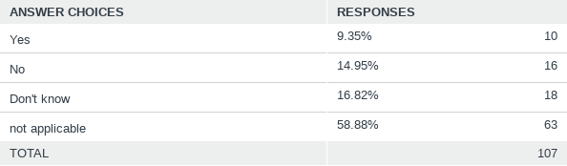

Comments
- Not that I am aware of. I have also never seen a plan from the school although I think they would claim there was one if challenged. However, some accommodations and support are in place.
- Didn’t even know this was a thing.
- He’s under SEND but there isn’t a comprehensive plan.
- But last time just sent a standard letter and didn’t even bother ticking which support given.
- No one has mentioned SEN Support.
- I haven't seen a support plan and no contact for 3 months now.
- School has refused to release the SEND support plan even though she is on the SEN register.
- Targets are terrible, no real focus on skills and they are not achievable or measurable "listen and pay attention 75% of the time".

8. Have you had an annual review of your child's EHCP that took place within a year of the previous review or within a year of the plan being written?
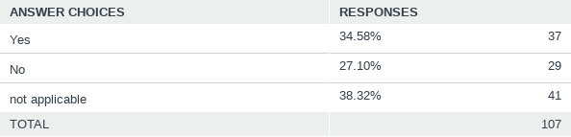
Comments
- Last AR Dec 2019. Crisis meeting with send officer attending March 2021, another due next week.
- The school has instigated and conducted annual reviews every year but WF have never followed up with a response on the EHCP.
- My child’s school are very pro-active and organised when it comes to annual reviews, even though the borough rarely turn up to them.
- No one from the LA has ever turned up to a review even after being invited by the school.
- Its been 2.5 years since the last review
- It’s due, it’s late, and only when prompted by solicitor was it looked at to be reviewed
- They had a short, incomplete and useless meeting that was supposed to have been an urgent meeting to discuss problems with the freshly issued plan, and they called it a Person-Centred Review. It was anything but.
- Had one in July 2020. Previously was December 2018 which was finalised February 2019.

9. How well do you think your child/young person's needs are met by the following service areas?

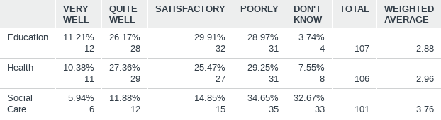
Comments
- my child attends a mainstream resourced provision however all he has is class teaching and a 2-1 LSA. There are no educational interventions
- We pay for private tutoring. What school can provide in terms of booster classes is limited and not using a specialist approach so while it is helpful, it would not be enough on its own.
- The school does what it can but it’s not equipped to deal with complex ASD
- Reports (following telephone consultation with paeds) v v slow to arrive--annoying when referrals are supposedly taking place. Audiology made it extremely clear to us at last visit that they were fitting us in during their lunchtime--this is a matter for their management & should not be moaned about to a parent!
- ONCE SHE TURNED 18, CHILDREN SERVICES REFERRED HER TO NELFT DISABILITY TEAM. THEY ARE DOING NOTHING ABOUT HER NEEDS. EG, PHYSIOTHERAPY, SPEECH LANGUAGE OR ADULTHOOD PREPARATION
- His mental health has suffered a lot due to all the inappropriate pressures on him and failures to address his needs and make accommodations.
- My son was asked to undertake a hearing test, and we are still waiting. Had an appointment booked for 6 Jan bit it was cancelled due to covid and never heard back

10. If your child struggles to attend school, does their school make reasonable adjustments for them to be able to attend school and reach their potential?
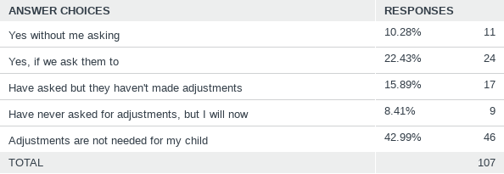
Comments
- Yes and no. It is college not school. Currently yes they are offering adjustments like offering reduced hours dropping classes, choosing what to attend, even just going for social meet up just to get son back into the building and also offering at last time with a learning mentor- but seems all too late.
- The school tries but he’s not there a lot so it’s hard for them to support him and also the adjustments they can make are limited and not really appropriate. With so many subject teachers at secondary they can’t all understand and adjust to his needs and some treat him as a ‘problem’ and report his coping strategies (eg head on desk) as ‘bad behaviour’
- He doesn’t struggle to attend school but school fights us on any adjustments. As they feel our son should adjust. Eventually they will come up with an idea and make it sound like their own (as long as our son is supported it doesn’t matter where the suggestion comes from). School do not like any parent input. So yes eventually some adjustments has been made.

11. If your child has an EHCP, do you know who your SEND Officer is?
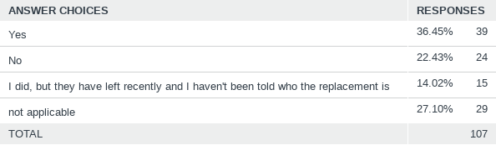

12. How do you rate communication with the SEND team?
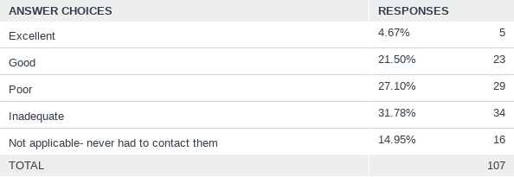
Comments
- Communication with SEND has been very poor for the most part. Some people have been useful but it's impossible to always find the right person and you are sent to various people. WF need to have a dedicated, central SEND department - one that actually responds to emails and phone calls.
- So many changes through the year at times have had to contact the very senior lead i.e. director for SEND to offer clarity on who will be addressing our query. The said leads have been on guard and asked probing questions as to how their details were found despite these being made available for service user should a need arise as they are in a public role and expected to be approachable- They are not very forthcoming and did not put me at ease due to their probing rather than an explanation of the changes the local department.
- There is no communication! It's always one way. We email them and hear the results from our child, by asking them if there are any changes. During the only meeting we had with SENCO and an educational psychologist, the SENCO was unwelcoming (didn't even say hi, huffed and puffed their way into explaining why we were having that meeting) and just muted themselves and switched off their camera for the rest of the meeting. We don't know if they were still present or not. Apart from this, communication has been none to very minimal.
- Communication with the SEND team is non existent - they have never contacted me and I wouldn’t know how to contact them if it wasn’t for the files on the Parent Forum FB page.
- High churn. Had 4 sen officers during the 20 weeks to get the EHCP! Tribunal officer has now left too and no one replies to our questions
- We only speak when there is an issue, as we have not had an annual review since the change in officer we have exchanged emails and had one phone call. I find they do not have the authority to challenge the school now they are allocated to one school. they lack confidence.
- Home Visitor are excellent, struggle with the rest of the team
- Had no problems with getting in contact with actual Sen officer bit during the process of getting on it was a nightmare getting in contact with team leads and EHCP was issued very late and only after constantly chasing them up and sendiass getting involved
- Mostly awful, particularly team leaders and above. Very ingenious, don't respond effectively or in timely way. Offer meetings and faux empathy and then don't follow through. Meetings become phone calls between one or more important meetings. So much talking and so little action and resolution. They seem incapable of listening and their apparent reading comprehension is abysmal.
- They do not respond to any communication unless repeatedly chased or threatened with formal complaint.

13.How could communication with the SEND team be improved?
- They need to reply to emails, even with just holding information. For them to explain the process.
- More explanatory more customer friendly more approachable more information and reasoning or guidance on the reform or restructuring of service. Limitations on how often the system may be restructured- pointless changes in position names and remit makes no difference to quality of pur experience. In fact feel more and more excluded/alien Directors should be more accountable and fearless of encounters or frankness towards the users of the service which they manage and publically answerable annually
- If they cared about their job and responsibility for the kids' lives thry would introduce themselves, keep in touch, plan reviews in advance, send minutes of meetings, update plans on time. Also they would bother reading the file before going to a meeting and offering nothing apart from saying well I don't know the child or the council won't agree to that.
- As a starter I would like to receive a letter or email from our SEND officer introducing themselves and explaining what they do and how they fit in to the whole process of special needs children’s lives. It would be good to have a dedicated online resource, message service, newsletter (that wasn’t out of date before we received it). I think they rely far too much on the Parent Forum for communication - there are parents of SEN children who are not members.
- Actually respond to emails. Pre-emptive emails when SEND officer leaves to let parents know who the replacement will be.
- Keep your staff and be more caring towards families and children with Sen! We are not against you, we want adequate support for our children!
- More centre and training staff
- Answer their phones, answer their emails. They clearly have too much work so there needs to be more Sen officers. They should be familiar with the children that they are supposedly advocating for
- Face to face or virtual meetings could be helpful.
- I think they should meet the children they are working for, so they get a feeling for this child rather than seeing them as a budget line on a spread sheet.
14. Do you think there are enough leisure activities for children or young people with SEND in Waltham Forest?
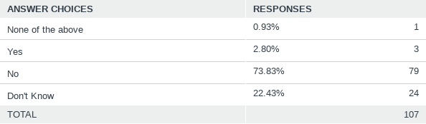
Comments

Parents generally don’t feel there are sufficient leisure services for children/young people with SEND. This has been made worse by Covid as many services are not operating fully, including short break services.
- Need more SEN specific sessions, eg quieter, less crowded
- Not at all varied enough or as robust as they were, Need more flexiblity if we need to buy something in lockdown and did not make the deadline date to use certain amount of hours to buy equipment we should allowed to do so later than the deadline. People have been sick with covid and caring responsibility for whole families has been upon them, so we can't all be expected to meet deadlines. This budget is for the young person to utilise and yr after is going unspent due to the rigid rules of service as above limited choice and inflexibility of the manager of the case lead/coordinator. please be open to suggestions of the family of the young person who are the only advocates for them. They do know what they need and the SEND need to start listening and endeavouring to meet them more than half way to use the funds that are rightly their to support the persons in question My worry is that countless families & young people are going without essential care and support not from lack of need but lack of utilising the fund ring fenced for them. The SHORT BREAK system of not having access to amount bot utilised in the past and the probing of cases where funds are reabsorbed to the council budget should be questioned. If the young person is still living then questions should be asked as to how they are supported if the funding set aside as a SB budget is not utilised for them. This will directly show if the council is doing their job well or not. So far I doubt they are as nobody has very discussed the stats on finances assimilated due to lack of uptake of users.
- Not at all. My son is only 2 and a half, but already I note there is only 1 play group for children with special needs (of his age group - Somewhere to Belong) and the other group specific to his actual diagnosis (DS) is under threat of closing/no longer running and it only runs once a month as it is - Shocking!
- There needs to be more training for all leisure activity providers. We had a bad experience with sports at local leisure facilities
- There could be more sports activities such as swimming/ karate/ horse riding. With lessons for kids with SEN.
- There are none suitable for my child. I would like him to be supported to access mainstream clubs if there is none.
- 1-2-1 swimming lessons and football would be a great start
- Needs flexibility to meet individual needs. Also needs activities for CYP with no intellectual disability and more moderate support needs, but who need support. Specialist swimming tuition, climbing club, other interest based social groups. Allow some groups to include siblings to make it easier and more accessible for families to attend.
- Absolutely not. There is nothing from what I can tell, it certainly doesn’t feel accessible. And what there is is in Walthamstow and we live in Leytonstone.
- Not enough diverse activities for all age groups and no activities where adults can stay and participate, which is the biggest barrier to accessing activities.

16. Does your child access short breaks?
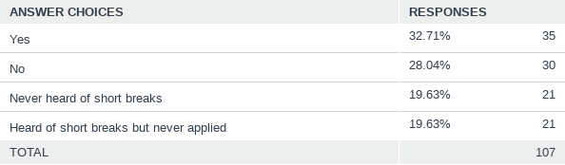

17. If you have accessed short breaks, how could the service be improved?
- I use the limes service but it’s only 10-3 but I work full time-sing patent this single income. I use the short breaks but then I have to pay and extra £15 per day and a member ship fee. I also then have to pay a childminder to take him and drop him off. There are NO facilities for a working parent with an autistic child available
- Feel so done in by the processes around WF and whether we would get anything worth having I can’t be bothered
- Employ more staff
- Funding for services that are appropriate to the needs of eligible children and young people.
- More hours? More choice for using the hours? -the chap that deals with the breaks is brill, very kind and understanding
- We have limited access as other areas are all booked so didn’t get a a chance to look for other providers so stuck with one provider since one year though he is happy with the outing
- Make it easier to get support. Admin is hard. Support kids to access inclusive things like Scouts, Guides, drama groups, after school sports club. Actually remove barriers to participation
- More activities that are short(30 mins to an hour), at convenient times and where parents can stay and participate or at least observe

18. Overall, how well do the services your child/young person uses help them to do the best they can in-
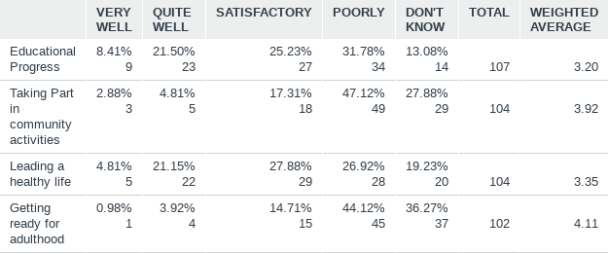

19. How easy do you find it to get information about services that are available and what they do?
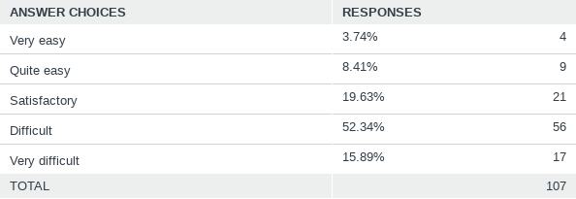
Comments
- Local offer is a shambles since it was first set up it has only gotten worse I can never navigate it to find what I need take calls to local links I have
- Only due to the Waltham Forest Parent Forum, I get all of my information from there, not the borough
- But that’s only because i am online all the time! People that aren’t would struggle
- Its a blessing to have the parent's Forum on face book where you can ask about anything and get professional advice instantly and free of charge!
20. Have you heard of the 0-25 SEND Local Offer?
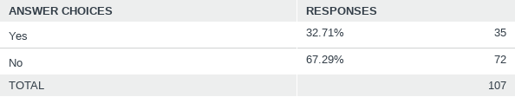

21. Can you please tell us of any positive experiences you have had with any SEND Service?
- Zoom calls we had over lockdown were very effective
- The EP report we received had great recommendations on it for school. As did the SAL report. I feel when these got put into the EHC plan though it all gets a bit lost. A lot of it now seems out of context. For example, my son when he was 1 didn't like the feeling of grass on his feet and that somehow translates to him having sensory differences as a 4 year old even though there is no other evidence of this and nothing in the reports. I was unable to get it removed
- Was surprised when informed of change of SEND officer by post, as wasn’t informed when there were changes before. Nice to be kept informed. Previous SEND officer (Sau) was good at following up tasks she said she would do
- We have worked with Children's Occupational Therapists in Wood Street, E17. My child has received excellent support from them and they really, really tried their best to help them in every way they could.
- Jolanta has been great as have the dentist and nutritionist.
- SENDIASS has helped and one Early Help worker was outstanding.
- Elhap via the short breaks service is fantastic.
- Camhs have always tried to help and Ed psych Wayne was very helpful in lockdown with phone calls
- SEND at the secondary school tried to understand his needs without a diagnosis and although he’s rarely they. They offered a range of flexible support and special interest classes, as well as full access to the ‘provision’ at the school and a flexible timetable. They have tried to support me as a parent and chased Camhs for a diagnosis
- SALT team are amazing. Gave a lot of support, support plans, referral parent to special sessions. Amazing
- CAMHS and SALT have both written very helpful reports with regards to my son's EHCP, the SEND officer has been really helpful, SENDIASS have been magnificent.
- Send provision my sons school offer is very good.
- My sons ADHD clinic appointments are always helpful, makes us feel as ease and gives us the right help.
- Community Epilepsy Nurse is extremely helpful and supportive - Marie Fleming
- Camhs - although a long waiting time and I have had to complain about this, the professionals are wonderful with my child and with me being anxious about the process.
- Somewhere to belong is great.
- The Waltham Forest Parents Forum is excellent and caters to all our needs and questions. Should be able to get this from our send officer!
- We had very good experience with our send officer Iliana while we were looking to get place for our son in school..she was very accessible and helped us in every way possible.
- The EP Cygnet course was good. The LO equipment offers during lockdown were great

22. Can you please tell us of any negative experiences you have had with any SEND Service?
- Early intervention is crucial for a child's development and it is proven that with the right support, conditions can be significantly improved. By not further focusing on early years and letting people stuck in it for months, children are not getting assistance when it is so crucial at their early age thereby creating more work for yourselves in the future. In other words, if a young person received the right support when he is 2 - 4 years old and the child condition improves significantly, the child will be needing less support further down the line. I appreciate that there are conditions that are harder to treat but i do believe that even these cases would benefit from early assistance.
- The waiting lists are too long for SALT. We've waited a year between each block of therapy. The therapy is repetitive. Not at all tailored to the individual child. I feel like its more of a box ticking exercise. I also think they've been very slow to move with covid guidelines and been extra cautious when there services are vital to so many families. Our EHC plan has left us feeling frustrated. We weren't listened to and the input we had wasn't valued enough to be copied and pasted into the plan properly. There has been confusion around allocating our son a school place which has left us feeling very stressed. And the SEN officer fails to take any responsibility for this confusion. And hasn't taken the time to explain why this has happened or what happens next. We have no confidence in them, which isn't helped by them being new and telling us they are knew all the time. It doesn't feel like they have enough support. It was the first EHC plan our officer had done, I think someone should have been in the co-production meeting with her.
- The SEN team have a high turn over of staff (many staff leaving and new staff starting) due to this emails can be missed and not responded to. Hence it leads to children being forgotten about and there EHC plans amended late. This results in SEN children not being accepted for their preferred choice of school/college being rejected as EHC plan haven’t been updated by local authority. My advise would be for a generic email being used and accessible to all SEN staff including their managers. The Council already uses Hornbill for various departments to ensure that emails are provided with a unique reference and allocated to specific staff and have full audit trail of responses and date/time of actions. If SEN team would like to improve there service to parents of special needs children then that would be the most logical step to improving their service.
- Lies, illegal criteria, failure to communicate, negligence, lack of any care about my son. This is an additional one: I was first contacted by a send officer in year 8 about a week before the deadline for the production meeting. She sent the plan in January 2016 and i never heard from her again. In year 10 I got advice from SENDIASS who said it should be about transition and I should ask for post16 officer to attend as well as send officer. Send officer came who I had never met or heard of. There hadn't been a proper review in year9 and no send officer. Post 16 officer didn't turn up so I arranged a meeting with him. He could not give much info on post 16 options but did wrongly claim the council would not fund out of borough college options and would not fund my son to do course at same level as before (e.g. to retake GCSE or functional levels) and also would not fund change of course and would cancel plan after internship as it's meant to lead to job. I queried this with managers as was very confused and worried what to do and eventually after a lot of rudeness a manager confirmed in writing that those things were not correct.
- EHCP process was terrible. Lack of information sharing between all the professionals. Do t listen to advice from parents and independent therapists who know the children well, churn of SEN officers, divisive and antagonist attitude with parents. Dreadful experience for parents who already have a lot going on in their lives and don’t need to fight more battles for their children. A true disgrace and the LA should be ashamed of the treatment they give to their constituents.
- Poor choice of language and attitude when speaking to health professionals. Generally, not much empathy with parents or children, the system is very clinical and all about budgets and staffing issues.
- EHCP assessment is like gold - not able to get and so many local “rules” which are not connected to original SEND Code.
- We seem to have fallen off CAMHS' radar during Covid
- EP report from Waltham Forest was non specific and so wasn't any good for my son's EHCP. EP and school claimed that this was so the school could interpret it according to what they could provide. School also claimed that they had to pay for any changes to the EP report and refused to allow my son to be seen, EP was adamant that school were meant to interpret.
- Since 2010 have been concerned that WF don't really understand what inclusion means and are content for families like ours to inhabit a parallel universe where we never mix with non disabled children now daughter has left South Grove's Provision.
- Appalling lack of support and inadequate communication regarding son’s secondary school exclusion. Furthermore, it transpired they had never updated his EHCP from primary school (5 yrs before).
- Lack of communication from send services, lack of annual reviews until I complain, lack of knowledge of basic send law from send officers. I feel like the support offered has to fit the shrinking budgets rather than thinking about the basic support my son needs to access an education. SENCOs seem to be routinely given misinformation by the SEN team (e.g. schools should keep EHCPs non specific, schools need to spend certain budgets and time before support is put in place, that there isn't budget for OT for kids with significant motor skill problems). Sencos blame the SEN team and the SEN team blame the sencos - every annual review we find ourselves put in the middle of a blame game.
- How long do you have... Bad mouthed to school staff about parents. Bad and unlawful decisions at every single step. Failed in basic statutory responsibilities, deadlines, etc. Failure to make statutory decisions on time. Give parents false/incorrect/untrue information. Untrustworthy. No one takes responsibility for decisions. Inadequate transparency about decisions. If the SEND dept had followed statutory guidance, communicated effectively, listened to parents and just done its job even moderately competently my son would not have missed out on years of support that he needed, would have made better progress, had better mental health and would have a plan that accurately describes his needs, with detailed and specific provision that meets all his needs. He would have a secondary place, we could have moved house with more than 1 bed, I could have returned to employment, and we wouldn't have to pay out thousands of pounds in professional fees to fight a tribunal. If they could do ONE thing different it would be to truly listen and prioritise the child, not local authority politics.

23.Based on parental feedback in 2020/21, there are several areas we feel we should concentrate on over the next year. Which do you think are the most important? Tick all those you think should be priorities. We are already involved in work on Preparing for Adulthood, the Autism Strategy , the Therapies review and an ADHD strategy so we haven't included these areas in the list
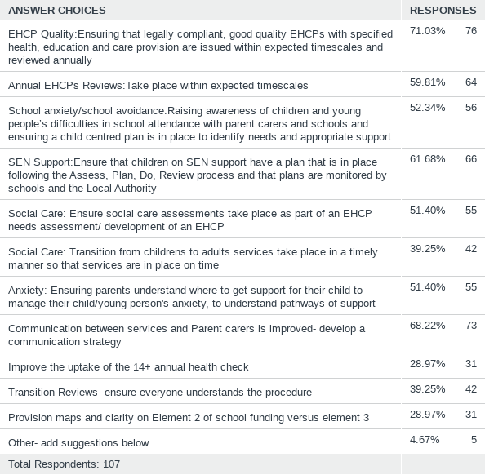

Additional Thoughts- Things to do differently.

Below are some suggestions of actions to take that parents feel are important.
We have fed back to various departments over the years, and we constantly discuss the same issues without them ever being resolved.
Communication between professionals and parents, for example, has been on the agenda since 2014(if not before) and it is still as bad as ever.
We feel now is the time to act on feedback rather than just listen to it.

- Truly listen and prioritise the child, not local authority politics.
- All SEND Team staff and all professionals who are part of decision-making panels, have at least the minimum level of legal training (IPSEA)
- Communication between professionals and parents must improve.
- Annual reviews- legal process needs to be followed and statutory timescales adhered to- currently only 63%
- Quality of reports and EHCPs to be prioritised.
- Better monitoring of SEND support for those with SEND support plans in mainstream schools.
- Social Care assessments must take place as part of EHCP process.
- More accessible information about services is needed.
- Better support for those with autism/learning disabilities who don’t meet CAMHS thresholds.
- Proactively listen and ACT on feedback more quickly

Other areas
Capacity of SEND team
Training budget- legal training
Lack of appropriate school places- esp. special school places- many children in mainstream school aren’t getting appropriate education
Not enough funding for short breaks/ not enough variety
Not enough specialist childcare for children/young people
Employment for LD
Council should take the lead and have YP in council departments as part of a supported internship scheme like Project Search
Fellowship Square café- internship at café?
Providers need to be more inclusive/provide specialist services- e.g., GLL/ LA picnic/garden party etc. No one should be commissioned if they aren’t inclusive

